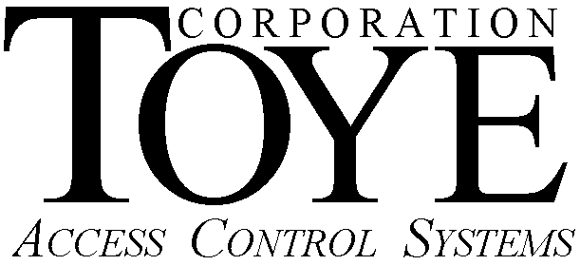

P.O. Box 3997, Chatsworth, CA 91313-3997, Phone (818)-882-4000, Fax (818)-882-5325, www.toyecorp.com

Important Daylight Savings Time Software Update

Due to the federal government’s changes in Daylight Saving Time (DST), all Toye systems must have a software upgrade in order to implement the new DST. Here are the options:

A. New Systems with Network Controllers (N.C.)
All N.C. systems will require an update in the Linux operating system to implement the new DST. You can verify that you have an N.C. system if you must click an Update NC button in most screens of the software to implement changes in the system. There are two options to update N.C. systems:
1. Order a NEW Flash Card for each N.C. The part number is 4200-FC-LNX. We are offering a special promotional price of $250.00 each for new flash cards ordered on or before March 11th, 2007. If your system has not been upgraded in a year or more, this is the best option. New flash cards have a number of updates that improved reliability and performance, and additional new features.
2. Order an email update, and install it yourself. This option is only for very computer literate individuals. Although the upgrade steps are fairly simple, if you make a mistake, you could damage the flash card beyond repair, and have to order a new one. The part number for this option is 4200-FC-EMDST, and the cost is $125.00 per site. You can upgrade all of your N.C.’s for one price. The warranty on this option is limited to a credit of $125.00 towards the purchase of a flash card.

B. Older Systems Wired Directly to a PC with Windows 95, 98 or 2000.
Microsoft has said that they will NOT update DST on Win 95, 98 or Millennium. For more information on Windows DST updates, go to the following web link:

http://support.microsoft.com/gp/cp_dst

1. If you are using Windows 95 or 98, you must order the DST update form Toye, and turn OFF the automatic DST in Windows, and turn ON the automatic DST option in the Toye Access Online software. The part number for the update is AC-DST-2007, and the cost is $125.00. It is best to place this order through your regular Toye dealer. If you want the update emailed to you, you can buy the update from Toye and pay by credit card (Visa or MasterCard), but you will have no local support, only telephone support.
2. If you are using Windows 2000, you should be able to download the DST update, and turn off the automatic DST in the Toye Access Online software. Running Toye software on a Windows 2000 PC is not recommended, and is very unreliable if you have Service Pack 3 or 4 installed, and/or if you have a large system, or if you have elevator control. The proper solution if you want to use Windows 2000 or XP is to order a Network Controller. For more information on this, you can view the following web link:

http://www.toyecorp.com/4200Specs.html

It is very important to install the DST update prior to March 11th, 2007 to insure the security of your system. If you do not have the update installed on March 11th, scheduled doors will unlock an hour early and security levels will be active an hour early.

DST2007.doc

